The mid section

One of the best known exercises for the abdomen, or stomach muscles, is the sit up. It’s also very commonly done wrongly, and can potentially cause strain.

Most people need to put their feet under something to weigh them down. If you’re lucky enough to have someone hold them, great, otherwise look for a handy bed or other piece of furniture. If you can do hundreds of these you may put strain on your ankles and foot tendons, but if you’re not at that stage, you probably will be OK. But a stretch and some flexing is a good idea before and afterwards.

Lie on your back with your knees bent and your feet flat on the floor. Cross your arms across your chest so each hand is on the opposite shoulder. It used to be popular to put the hands behind the head but this has caused neck strain. You need to keep those arms still, as you need to isolate the stomach and make it work. Now sit up. As you sit up, straighten up so that you’re sitting upright, not with a curled back. If you’re new to this you probably don’t need to do many. Try doing ten, and repeating this three times, then see how you feel the next day. You can increase the number each time, and the number of sets, as you learn how well you get on with them.

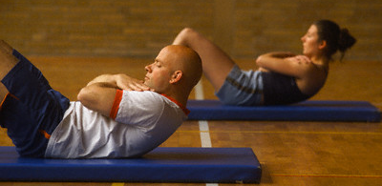

If you’re feeling happy with them, you can try some more advanced targets:
Do as many as possible, then set targets for following sets that decrease regularly.
Eg 70, 65, 60, 55, 50, 45, 40
Or 100, 90, 80, 70, 60, 50, 40

How many can you do in two minutes?
Or ten minutes?
In an hour?

Would you get into the US Army?

Two minute sit up test
Men & Women

 | Age 20 | 30 | 40 | 50
Pass | 53 | 45 | 38 | 30
Good | 66 | 64 | 57 | 48
Excellent | 78 | 82 | 76 | 66
To make sit ups harder (if you need to), use a weight. If you hold anything with a bit of weight behind your head, this will make it much harder. If you have two similar weights (eg a pair of boots or two bottles of water you can hold them with your arms folded across your chest as normal.

Crunch
Sit ups can put strain on the back. Crunches are a lot easier on the back and also provide a different option. Start from the same position. Tense your stomach to lift your shoulders off the ground and bring your ribs close to your pelvis. The small of your back (the lower back close to your backside) should remain tight against the floor. There’s very little movement, you only move your shoulders a very small amount.
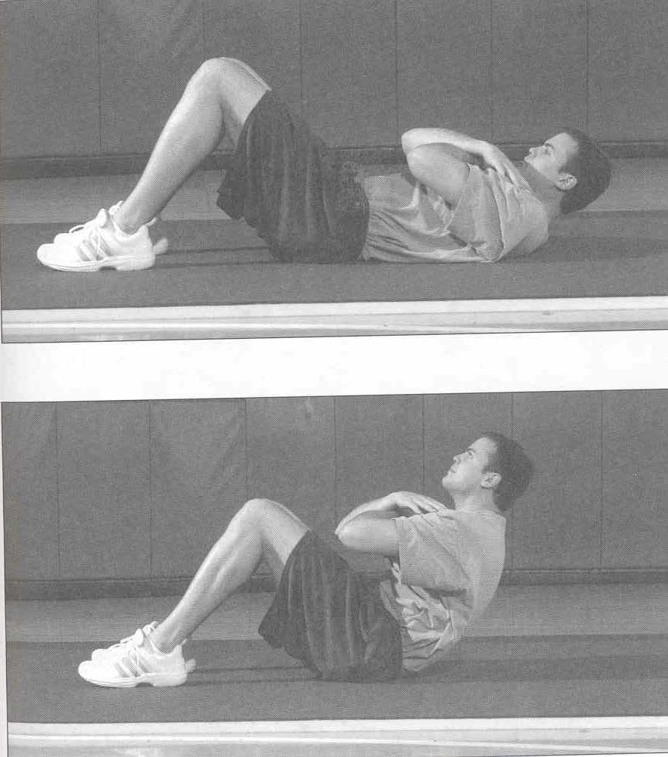
Variations
Twist – bring the left elbow up to the right knee, lie back then do right elbow to left knee.
Weight – Hold something across your chest.

The V-Up

This is used extensively in the military and works the stomach muscles hard. Lie on the ground with your hands on the ground next to your backside. Keeping the legs straight, bring both your shoulders and legs off the ground, so that your body is in a ‘V’ shape.

If you can do these easily, slow them down, and hold the top position for increasingly longer times.

Start...... ...and finish
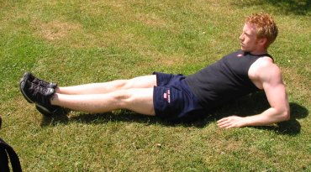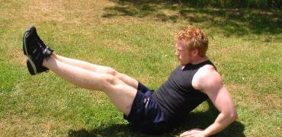

The Plank

This is a serious exercise which will work those muscles as hard as any exercise you will ever do.
Lie on your front, then raise yourself up on to your elbows. Your back is straight, and your weight is on the elbows and toes only. Now hold.

You will really work those muscles hard if you do 1 minute three times – with a minutes rest between each one. If you can do longer, do longer. A very effective exercise.
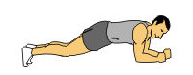

A variation of this would be the side plank. Give it a try!
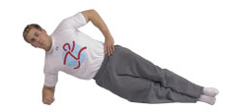

Spider Plank
If you can do the standard plank, try doing a Spider plank. From the same position, spread your legs apart. Move your elbows as far forward as possible, so your head is by your elbows, not over your hands. The objective is to make it as difficult as possible for yourself. This is seriously hard work!
Leg throws
Lie on the floor, near something heavy (eg a bed) that you can hold on to. Raise your legs so that they point straight up. Now let them fall, keeping them straight but stop them before they hit the floor. Then bring them up to the start position again.
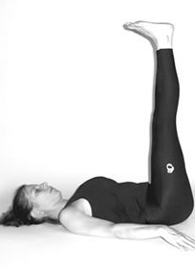
Position (without holding on to a support)
A variation that makes this extremely effective involves a partner. They stand over you, one foot either side of your belly, facing the direction of your feet. Bring your feet to their chest, and hold on to their legs for support. Have them push your feet away, and you need to stop them hitting the floor and bring them back. Keep talking to them, let them know whether to do it harder or softer.
Leg hold
From a similar position (on your own) you can just hold the position with your feet just off the floor. Aim for a minute.
Vertical crunch
From the same position as this you can do vertical crunches. Just push upwards with your hips.
The back
The back muscles are often forgotten, but it’s important to give them a workout.

Back Extensions
Lie on your front with arms at your sides. Slowly raise your body, pulling using the muscles in your upper back, not your head. To make it harder, put your arms out in front of you.
