Cardiovascular work & fitness programmes

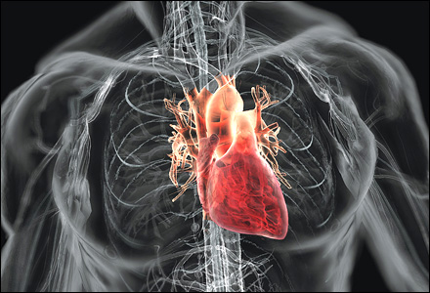
Cardiovascular exercises are those that are not specifically aiming to build a strength, but to build general fitness.

Running on the spot is a good standard way to warm up and will also be useful as an all body exercise. To make it harder try raising your hands up so your thumbs are level with your eyes. An alternative is lateral jumps, just moving backwards and forwards over a line – effectively just jumping side to side.

Star Jumps
Star jump
Also good as a warm up or beginner exercise. Stand with feet together and hands by the side. Then jump so to a position where the legs are apart and the arms out to the side – like a star. Return and repeat.

More advanced is an exploding star jump. The start position is a crouch with feet and hands together on the floor. Then jump to the star position.

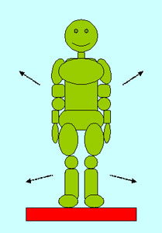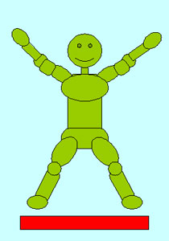

Exploding star jumps
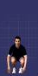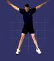

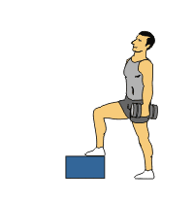
Step Ups

You need something to step on to - a box, stool or similar. Stand in front of it, then walk up on to it, one foot at a time (left then right). Step down left then right, then repeat. After a few minutes, try with the other foot leading. To make it harder, carry a weight.

Running on the spot

Not very interesting but can be a relaxing way of exercising. To make it harder, try lifting your arms higher so your thumbs are above your eyes.

Skipping

Skipping is exceptionally good exercise for overall fitness and keeping the feet strong, which is why boxers do so much of it, to keep them light on their feet.

Skipping ropes are available, some are leather, although you can get them in a plastic coated wire. They can be made from other things you may have access too, although they need to have a weight to move in the right way, so most string is not suitable. Washing line is excellent.

To start with, just try to get moving. You may want to do intervals – eg 3 mins followed by 1 minute rest, then repeat a few times. As you get better, you can try to go faster. Tricks can be going backwards, or to jump so high you get two turns in one jump.

Mountain climbers
Mountain climbers are hard: start like a sprinter in the blocks, waiting to start. Keep your hands on the floor and swap the position of the legs, so the opposite one is forward by your hands, and the other is stretched out behind. Then swap again. See this in the ‘Legs’ section.

Squat thrusts
Squat thrusts are also hard for the beginner. Start by crouching on the floor, hands on the floor by your shoulders. The knees are bent and the knees close to your chest. Next, thrust the feet out by straightening the legs. Then bring the feet back to the start position. Repeat without standing.
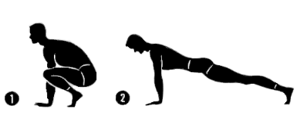

Burpees
Burpees are similar but involve standing up in between each thrust. When the feet stop with your legs bent (position 1, above), stand, then drop and thrust again.

There’s variations on these, eg:

Press up:
As you kick your legs out (position 2), drop your chest to the floor, and push up to straighten your arms before pulling your legs back.

Jump
As you stand up, jump. The height of that jump depends on how hard you want to work. If you’re at a high fitness level, try jumping up and tucking your knees to your chest before landing and starting again.

Lateral jump
After standing, jump to the side, or jump to face the opposite way before starting again.

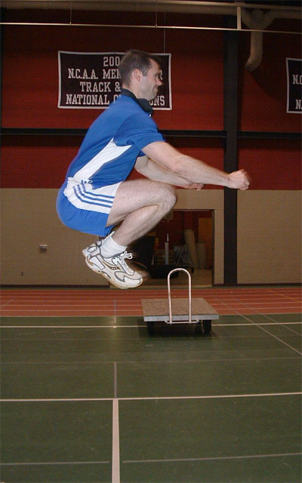
Tuck jumps
All you have to do is jump high enough so that you can tuck your knees against your chest, and still have enough time to land on your feet. A quick bounce, then repeat. Few people can do many without the bounce in between – try it if you’re feeling good. This is quite an explosive exercise –how many can you do in 30 seconds?

Stomping grapes
Lift your knee high so that it comes up to your chest, then put it down and do the same with the other leg. Repeat as many times as you like.

Putting it together

Putting together your own programme is something you will get the hang of, but some principles are handy.

Heavy strength work like press-ups, squats etc. Will leave that part of your body needing time to recover. Leave a day in between, don’t do this every day. You will need at least one rest day a week, where you do nothing, but alternating between different types of exercise will enable you to train while still resting. So, after a heavy day of training your arms and upper body, the next day you can train your legs or stomach muscles.

Example programme:
Monday – Strength work on arms
Tuesday – Cardiovascular
Wednesday – Legs
Thursday – All over training
Friday – Arms and upper body
Saturday – Cardiovascular
Sunday - Rest

Your most important equipment
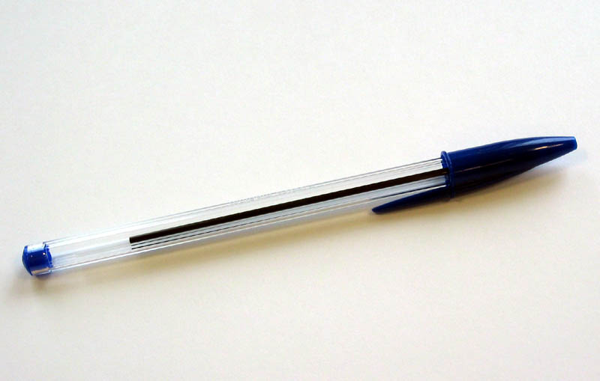

Most of the exercises you need don’t require any equipment, but a pen is essential. Write down what you do. This will enable you to look back and check what you’re doing, so that you can see that it’s all-round training. What you’ll probably do more is see your progress and see how your numbers are going up. Note your personal bests and allow yourself some satisfaction at beating them.

Some people like to keep weekly targets of how many of specific exercises they will do. Others have monthly, or even yearly targets.

Sets & Reps

Some exercises will exhaust you after doing a certain number. Often its a good idea to rest, then repeat the exercise. The terminology is that you are doing sets of reps (repetitions). For example, if I do 20 sit ups, rest, 20 more, another rest, then a final 20, I have done 3 sets of sit ups, and each set was 20 reps.

The most effective programmes will involve a range of exercises that have a range of effects. This can involve spreading the exercises over a range every time, or alternatively you could target different things on different days. Everyone has different abilities and objectives, so this will mean that everyone’s programme is different, but make sure you have variety.

The exercises below are suggestions, you may want to start your own or start from these. All should start with something to warm up before doing anything strenuous.

Overall programme:

Skipping – 3 minutes

Press Ups x 15
Chair dips x 15
Hindu Press Ups x 10
Squat x 10
Lunges x 15 each leg
Hindu Squat x 10
Calf raise x 10
Dorsal raise x 10
Sit Up x 20

Return to Press Ups and repeat for 3 sets.

Overall 2
Raised hand press Ups x 10
Crunches x 20
Mountain climbers x 20
Burpees x 15

Repeat four times.
This could be a flexible programme, as you could increase the number of reps, or have double sets each time.

Each exercise could be altered as you get better. For example, the press ups could be made harder by raising the feet higher, moving the hands further apart, or moving to harder exercises like Hindu Press ups.

Legs

3 mins running on the spot

15 lunges each leg
10 squats
15 Hindu squats
20 lateral jumps
3 one leg squats each leg

Repeat 3 times.

Try your own programmes. It’s easy to make them too hard to start with, remember if you haven’t trained for a while, it will take time to get back into it, and you will improve quickly. Start with small numbers and lower impact, and be prepared to improve them.

Deck of cards
Try this exercise – it will make you sweat, and introduces a level of unpredictability. This is so versatile you can use it again and again. All you need is a pack of ordinary playing cards.

Shuffle them – and you may want to spend a long time doing this, because you’ll not be pleased with a badly shuffled deck later! Now pick four exercises that you can do a reasonable number of (you’ll be doing 85 of each). In this example we’ll use Press ups, sit ups, star jumps and squats. Now write down the four suits, one next to each exercises, eg:
Clubs – Press Ups
Spades – Sit ups
Hearts – Star jumps
Diamonds – Squats.



Now turn over the first card. The suit tells you which exercise you’re going to do, the number tells you how many. So if you have the 8 of Diamonds, you need to do 8 squats. Jack, Queen and King each mean 10, Ace means 1. You can keep jokers in to mean something else, so in this one they could mean 20 burpees (or they can be ignored). Go through the whole pack, one card at a time, and you will have had a random workout.

As you get fitter you might want to try going through the deck faster, or try swapping easier exercises for harder ones. The ace can change to15.

If you’re planning a leg workout, just pick leg exercises. This is a very versatile method, and the random aspect makes things more interesting.

Two minute rounds
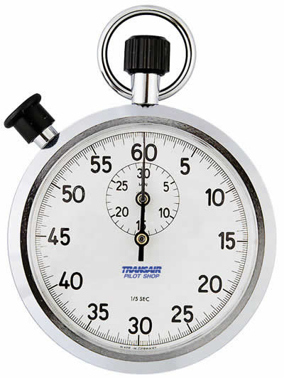
This method is used by amateur boxers in training because it’s intensive. It needs your exercise to be timed. Having a training partner is handy, but many cheap digital sports watches have repeater countdowns which are very helpful. The repeater countdown can be set to any time you like, and will countdown and sound an alarm, while immediately counting down again. Whether you’re using this or a training partner or watch, you need to do each of four exercises for 30 seconds.
Try:

Press ups – you can drop your knees from the start or partway through as needed.
Sit ups
Dorsal raises
Tuck jumps. Use star jumps if tuck jumps are just too hard.

Do each as fast as you can for 30 seconds before moving on to the next without stopping. At the end take a one minute rest before repeating, then rest and do a third round. If you can get a timing buddy to write down your numbers each time that will show how you progress. This is an exercise that will help you build explosive power and fitness, not endurance. There’s no need to change any exercise for a harder one because the idea is to work hard and do as many as possible. You can choose easier ones if you need to increase your number of reps, but try to keep to the same muscle groups.

Tabata Intervals

Studied by Izumi Tabata, a Japanese scientist, these intervals were based on a speed skating training technique, and have been proven to improve your performance over short periods – like sprinting.

The idea is to work at maximum intensity for 20 seconds, take 10 seconds rest, and repeat. So you could sprint, or perform almost any exercise for 20 seconds at a time with a 10 second rest between. Aim for 4-6 sets. If you can do these easily, you need to work harder at the intense periods. Try doing press up s for 20 seconds at full speed, resting for 10 minutes then going again for 20 seconds to see how intense this is.
Suggested exercises for Tabatas:
- Step ups
- Squats
- Dorsal raises
- V-Ups
- Almost any exercise you can think of!

- Press ups
- Power overs
- Sit ups
- Burpees
- Shadow boxing

Stretching

As you train and build muscle your body rebuilds muscle shorter and thicker. Stretching is essential to return the muscles to the original length, and keep your tendons in good condition. All stretching should be done slowly, putting pressure on, not in a jerky or ‘bounce’ way. It shouldn’t be hard work, and should never hurt, just stretch enough to feel the tension.

Example stretches:

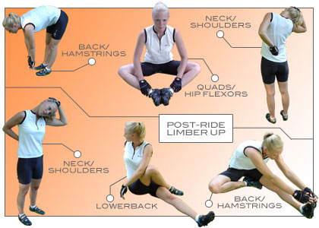

For your back and hamstrings (tendons that run along the back of your knees). Keep the legs straight on the first one. On the second one make sure the knee is straight on the straight leg. Swap over and do both legs.

This is useful for the adductors, which run across the groin to the thighs.

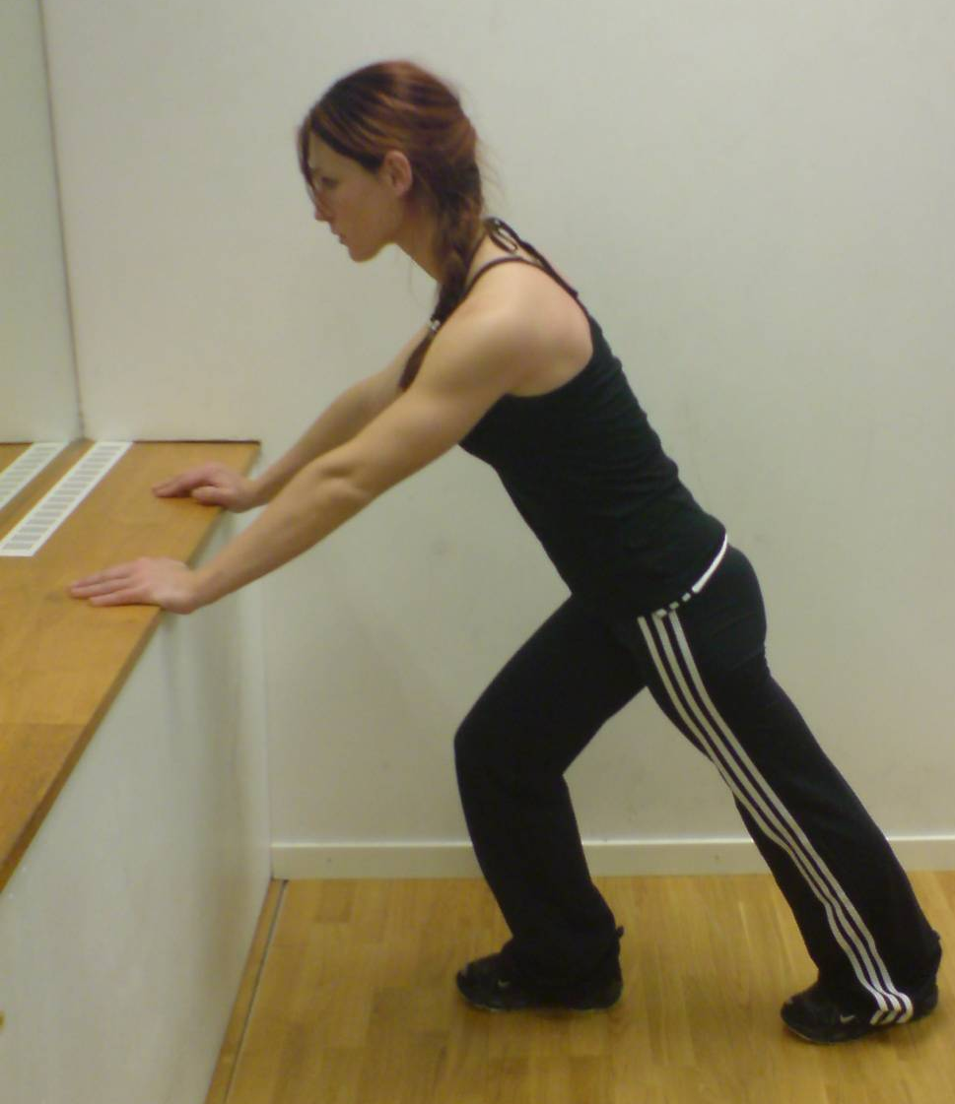
Calf stretch – the back foot has the heel on the floor. As you push forwards, the calf takes the strain and stretches. Apply pressure carefully. Always do this after running or leg work outs.

Hip stretch: Groin tendons:

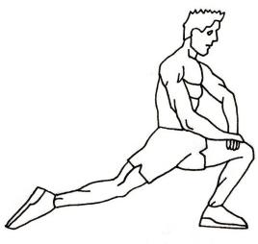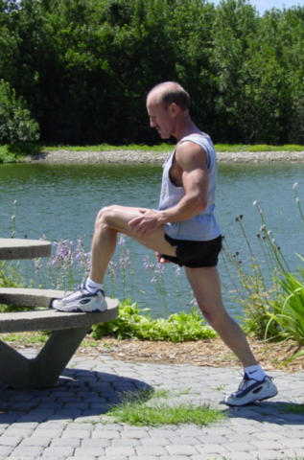

Lower back:

Stretch regularly and loosen those tendons in areas you’ve worked.

Enjoy your training is probably the best advice anyone can ever give you.

This guide was put together by your friends at www.veganfitness.net, the online sports community for vegan athletes from professionals, record holders, club members, fun runners, beginners, strugglers and every other type of vegan of all levels. Come and visit us online when you’re able to.

