LEG EXERCISES

Squats

Legs are almost always the strongest muscles in the body, and developing the muscles helps with speed, endurance and power. Squats are the first exercises you need to use.

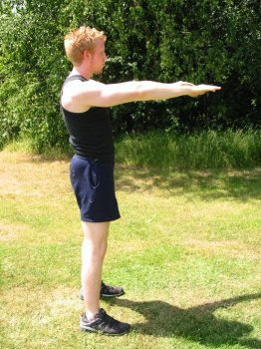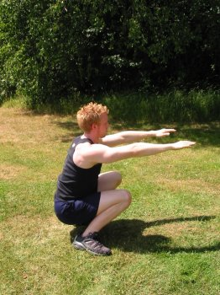
Stand with your feet a little over shoulder width apart. Keep the back upright and bend the knees to drop yourself down. When you reach the point where your legs are at right angles, straighten the legs again. This is a controlled movement, there should be no bounce, and the objective isn’t to move quickly.

Once you have the hang of these, start by doing a few with your feet close together, then further, then Power Squat with your feet as far apart as is practical.

If you can do these in high numbers, you can try using weights – some people do them with a barbell across the shoulders, or even with someone riding piggy back.

Another way to make them harder is with kicks. You need to have warmed up and stretched really well for this. When you come up after the squat, keep one leg straight, and kick it upwards. Some people aim for the foot to come up level with the shoulder, but you have to be comfortable with both the balance and the flexibility you have. After the kick, do another squat and repeat with the other leg.

There are other squat variations you can use.

Hindu Squats

These are a terrific exercise which really work the legs and help you develop the quad muscles – the muscle on front of your thigh used in running, climbing and by martial artists in developing strong kicks.

Stand upright, and hold your hands by your sides. Squat all the way down, so that your feet rock forwards and your heels come off the floor. Your backside should come right down to your calves (the back of your legs, below the knees). Then push upwards. As you come up, your arms should swing forwards, so that as you reach the upright position, they’re straight out in front of you. Balance can be tricky, so keep your head up – look up where the wall meets the ceiling ahead of you. And give those arms a big swing, your hands should come as high as your eyeline.

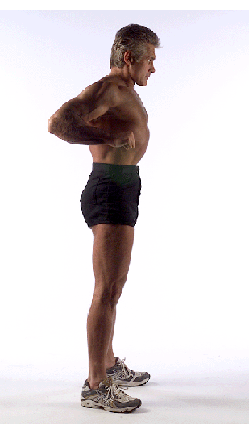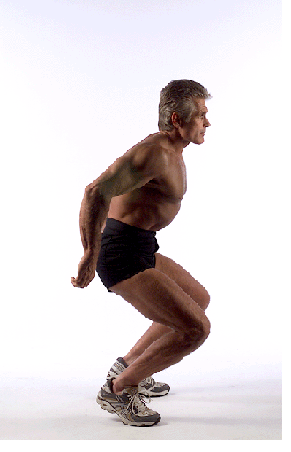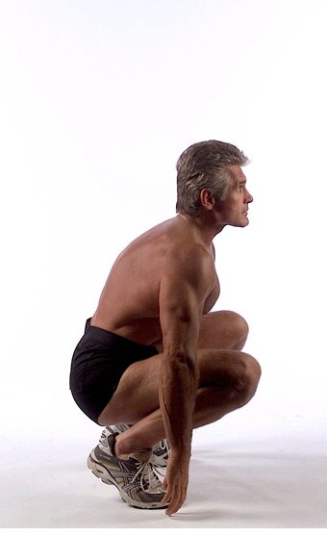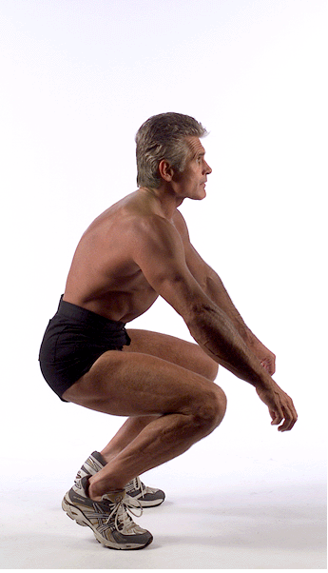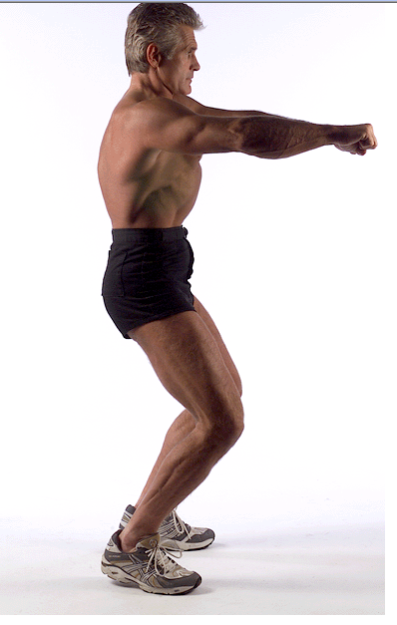

This isn’t an easy exercise, but stick at it because the benefits are well worth it. Breathe out on the way down and in on the way up. To start with just aim to get them right, then start to build up the numbers. Twenty five is a good target for a beginner. But be careful with these – large numbers early on can mean you over do it easily. And if you feel pain in your knees, during it or up to a day afterwards, you need to stop doing them. This put a lot of pressure on the knee caps.

Leg press ups

A good way of building those quads quickly is to use press ups for the legs. This time it’s a good idea to use a nearby doorframe or chair just to help with balance. This time, stand on the balls of your feet, and push your hips forward. Push your head and shoulders back as far as possible so that you’re leaning back, and use the door frame or chair for balance. Try to look up at the ceiling. Now, very slowly, start lowering yourself down. It should take four seconds to go down as far as you can, then another two to get back to the beginning again.

This is a very hard exercise on those quads, and ten is a good target to start. You will feel this in your legs as it’s so powerful. Bearing in mind that 10 reps will only take you one minute, this is a great effect for such a short time.

Lunges
Stand with your feet close together, then step out with your left leg. Lunge deep and low, but make sure your left knee is over the foot – the knee should not pass the toe. Push back and repeat with the other leg. Aim for ten each leg, then slowly build up, it’s easy to overdo this one. Along with the squat, this is essential to building leg strength for running and other exercises.
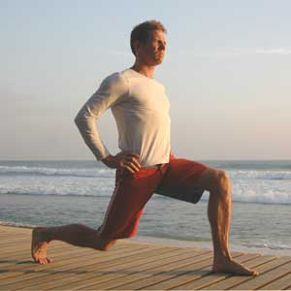

Single Leg squats

This is a really serious squat for anyone who has some leg strength. Most people find the balance really difficult, so use a door frame or something else solid to hold on to.

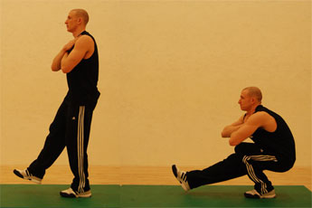
Stand on your left leg and put your right leg in front of you, off the ground – your left leg is taking the weight. Lean forward. Now you need to bend that supporting leg and go right down, so that your leg has gone past right angles. The next bit is the hard bit – coming back up. You need to straighten that left leg to get back up to standing. It’s tempting to pull on your door frame with your hands, but this is just for balance – the leg has to be doing the work.

Then you need to swap and do the other leg.

Plyometrics

Plyometrics are exercises that involve jumps. Once you have the basics of an exercise, bringing jumps in can give you the muscle conditioning that will bring real power.

An easy but effective way of doing this is to use the vertical jump. It really is as simple as it sounds – just squat down as low as possible, and then try to jump as high as possible. This can be repeated in sets – try sets of ten. Mind the ceiling with your head!

For a variation try jumping high and trying to land facing the other way.

If you do fifty normal squats, next time try adding a jump on the end of each squat. As you come up, push with enough effort to get yourself airborne, then land in the same position as when you come up after a normal squat. This will work you legs really hard.

Lateral jumps are excellent for fitness, and work your legs too. If you have lines (eg tiling) on the floor, or can put a piece of string or other line marker down, this can help. Stand to one side, and jump sideways, then return to the start position. Keep repeating this, it’s like going for a run without having the space. If you really want to make it harder, jump higher each time. You could even lie something down to jump over. But remember you will get tired and eventually you will hit whatever you’re jumping over – so nothing that’s going to actually trip you.

Tuck jumps are an intense exercise that will help you develop explosive power in your legs. Jump high and bring your knees up tight in to your chest. Then you’ll need to get them down in time to land! Not many people can do these for long, try to build up to 30 in a row without stopping using a constant rhythm.

If you have a small space, try making small jumps forwards. Keep your feet together and jump as if you were trying to clear a small obstacle, something about as high as your shin. Keep your feet together as you land, and bend the legs. Your muscles should absorb the shock of landing, not your joints.

Plyometric lunges

Once you’ve used the lunge, you’ll know what a great exercise they are for your legs. Plyometric lunges will really have you working hard. Stand as if you’ve just done one lunge. Next you need to bend both legs so that your thighs are parallel with the ground, then jump and swap your legs over. Repeat.

You may have seen children do this playing – but you could do it to build up those thigh muscles. Crouch down as low as you can. Now try to jump as far forward as you can, like a leaping rabbit or frog. Try five to start with, or try hopping across a small room a couple of times. If you do too much of this to start with you’ll easily overdo it.

Another variation from the starting point is just to walk without getting up. Keep your shoulders and hips as low as before, and walk. Hard work!

Flutter Kicks

This sounds a lot easier than it is. Lie on your back and raise your feet just off the floor. Your heels should be about 6 inches (15cm) off the ground. Move one leg up another 15cm, then swap the position of your feet. And again. Keep repeating. This one is used in the military and after a while becomes hard enough to reduce those soldier boys to tears.

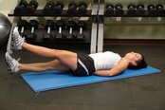

Mountain climbers

This one is good for overall fitness as well as your legs. Start by taking up a press up position, hands and feet only on the floor. Then move one leg right forwards, a bit like a sprinter at a crouching start, but much lower. Next, swap your feet over, bring the back one forwards while the front one shoots right back. Keep swapping. Try sets of twenty – a complete exercise involves two swaps – so you’re counting the number of times one particular leg comes forwards (not either leg).

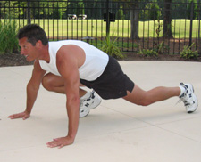

Leg raises are a lower impact exercise but great for building strength in those legs. Lie on your back, with your leg straight and the toes pointed. Raise the leg under control as far as you can without bending it, then take it back down without touching the floor, and repeat. The slower the better.

L-Seat

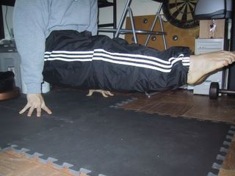

Just try to hold yourself in a position, off the ground, so that your legs and body make an L-shape. A few seconds is good to start with - this is a hard exercise!

The chair hold
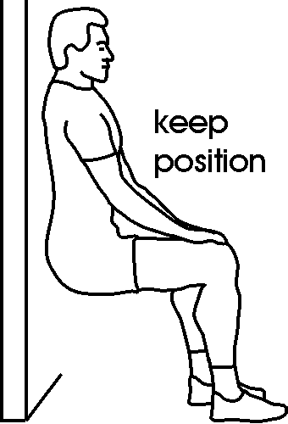
This is a static exercise that will work your legs so much just to hold it. You need to position yourself in a sitting position so that your back is flat against the wall, and your knees are at right angle. It’s as if you were sitting on a chair…but there’s no chair. It’s the strength in your legs holding you against that wall that stops you from falling. Hold for as long as you can. For most people, it’s the pain and the mind giving up that stops this exercise. Push yourself and make this work. If possible get someone to time you and increase your target time each occasion.

Calves

Lots of leg exercises are for the larger muscles above the knee, but remember that you have important muscle groups lower down. The calf muscle, below the knee on the back of the leg, can be exercised by a simple exercise. Just raise your heels off the floor so you’re standing on the balls of your feet, and slowly back down again. You can repeat this one as many times as you feel comfortable. To make it more effective, try it on a step so that the heel goes down lower than the toes each time. If you haven’t got a step, try standing on an object – maybe a book.

To make it harder, hold a weight as you do it.

Hanging Leg Raises

You will need something to hang from – if you have access to a tree branch you can do this, but the chances are you will have to wait until a visit to the gym. Grip on and hang. Now you need to raise those legs, like in the normal leg raise exercise. This is an advanced exercise – if you get a chance, give it a go.
-